

19AIE104-

Electrical Engineering

Low-pass RC filter

Abijith (CB.EN.U4AIE19002)

G.V.S.Rajaneeshwar (CB.EN.U4AIE19027)

G.Rohith (CB.EN.U4AIE19026)

**Title:**

Low-pass RC filter

**OBJECTIVE :**

The objective of this lab activity is to study the characteristics of passive filters by obtaining the frequency response of a low-pass RC filter.

**CIRCUIT DIAGRAM:**

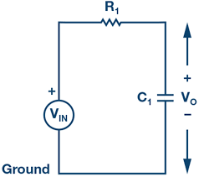

At low frequencies, the impedance of the capacitor will be very large compared to the resistive value of the resistor, R. This means that the voltage potential, Vo, across the capacitor will be much larger than the voltage drop across the resistor. Therefore, at high frequencies the reverse is true, with Vo being small and VR1 being large due to the change in the capacitor impedance value

The cut-off frequency for an RC filter:



**MATERIALS REQUIRED:**

1. ADALM1000 hardware module

ADALM1000 is used to make the relationships

between current, voltage, impedance (inductance,

resistance and capacitance) to the user.

This device consists of several inputs like Channel A ,

Channel B, 5 Volt, 2.5 Volt, Ground

AliceM1k Desktop software is used to measure the

Channel A, Channel B voltage or the current to which

ADALM1000 is connected with PC it shows in the form

of graphs by selecting which type of curve we want.

We can select mode like SVMI or SMVI and the shape

of the curves like DC, sine, and sooth tooth by giving

minimum and maximum voltage of Channel A. we can

also select the frequency of the Channel A and Channel

B.

In curves menu select CHA voltage avg , CHB voltage

avg.

In this we also have to give CHA voltage per division .

CHB voltage per division.

1. Resistors (1 kΩ)

It is a material having a specific resistance taken in the circuit to calculate the cut-off frequency.

1. Capacitor (1 μF)

It is a material having specific capacitance taken in the circuit to calculate the cut-off frequency.

1. Breadboard

A breadboard is a solderless device for temporary prototype with electronics and test circuit designs. Most electronic components in electronic circuits can be interconnected by inserting their leads or terminals into the holes and then making connections through wires where appropriate.

1. Jumper wires (3)

The wires used for completing the circuit connection.

**ADALM SOFTWARE SETUP:**

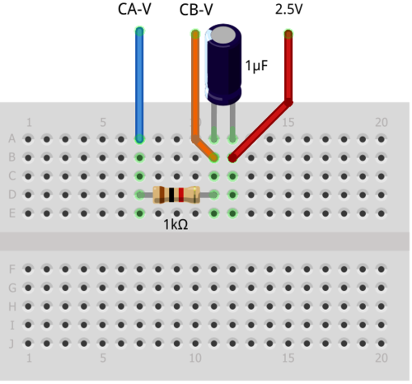

**PROCEDURE:**

1. Set up the RC circuit as shown in Figure 2 on your solderless breadboard, with the component values R1 = 1 kΩ, C1 = 1 μF.

1. Set the Channel A AWG min value to 0.5 V and max value to 4.5 V to apply a 4 V p-p sine wave centered on 2.5 V as the input voltage to the circuit.
2. From the AWG A Mode drop-down menu, select SVMI mode. From the AWG A Shape drop-down menu, select Sine. From the AWG B Mode drop-down menu, select the Hi-Z mode.

1. From the ALICE Curves drop-down menu, select CA-V and CB-V for display. From the Trigger drop-down menu, select CA-V and Auto Level.
2. Set the Hold Off to 2 (ms). Adjust the time base until you have approximately two cycles of the sine wave on the display grid. From the Meas CA drop-down menu, select P-P under CA-V and do the same for CB. Also, from the Meas CA menu, select A-B Phase.

1. Start with a low frequency, 50 Hz, and measure output voltage CB-V peak to peak from the scope screen. It should be the same as the channel A output.
2. Increase the frequency of Channel A in small increments until the peak-to-peak voltage of Channel B is roughly 0.7 times the peak-to-peak voltage for Channel A.
3. Compute 70% of V p-p and obtain the frequency at which this happens on the oscilloscope. This gives the cut-off (roll-off) frequency for the constructed low-pass RC filter.

**Calculations :**

P-P Voltage of sine wave = 4.0 V

4 * 0.7 = 2.8 V (P-P)

Find out the frequency where the P-P of CH B drops to 2.8V We will find it out at 160 Hz. If we increase the frequency further the P-P of CH B will further decrese. You will find sharp decline in voltage after 230 Hz

From formula :

fc = 1/ (2*3.14*R*C) =

1000000/(2*3.14*1000*1) = 159.2 Hz

**RESULTS:**

|  |  |  |  |
| --- | --- | --- | --- |
| CH A Voltage(P-P)  Voltage | CHA frequency    Hz | CH B (P-P)    Voltage | Cut of frequency= fc=  1/(2*3.14*R*C)  Hz |
| 4.0 V | 120 | 3.1012 V | 159.2 Hz |
| 4.0 V | 130 | 2.9725 V | 159.2 Hz |
| 4.0 V | 140 | 2.8756 V | 159.2 Hz |
| 4.0 V | 150 | 2.8119 V | 159.2 Hz |
| 4.0 V | 160 | 2.6921 V | 159.2 Hz |
| 4.0 V | 170 | 2.6014 V | 159.2 Hz |
| 4.0 V | 180 | 2.5197 V | 159.2 Hz |
| 4.0 V | 190 | 2.4362 V | 159.2 Hz |
| 4.0 V | 200 | 2.3714 V | 159.2 Hz |
| 4.0 V | 210 | 2.2998 V | 159.2 Hz |
| 4.0 V | 220 | 2.2211 V | 159.2 Hz |
| 4.0 V | 230 | 2.1713 V | 159.2 Hz |
| 4.0 V | 240 | 2.1052 V | 159.2 Hz |
| 4.0 V | 250 | 2.0431 V | 159.2 Hz |
| 4.0 V | 260 | 1.9781 V | 159.2 Hz |
| 4.0 V | 270 | 1.9248 V | 159.2 Hz |

**SCREEN SHOT:**

At frequency=150 Hz the Voltage CHB is approximately equal to 0.7*CHA Voltage

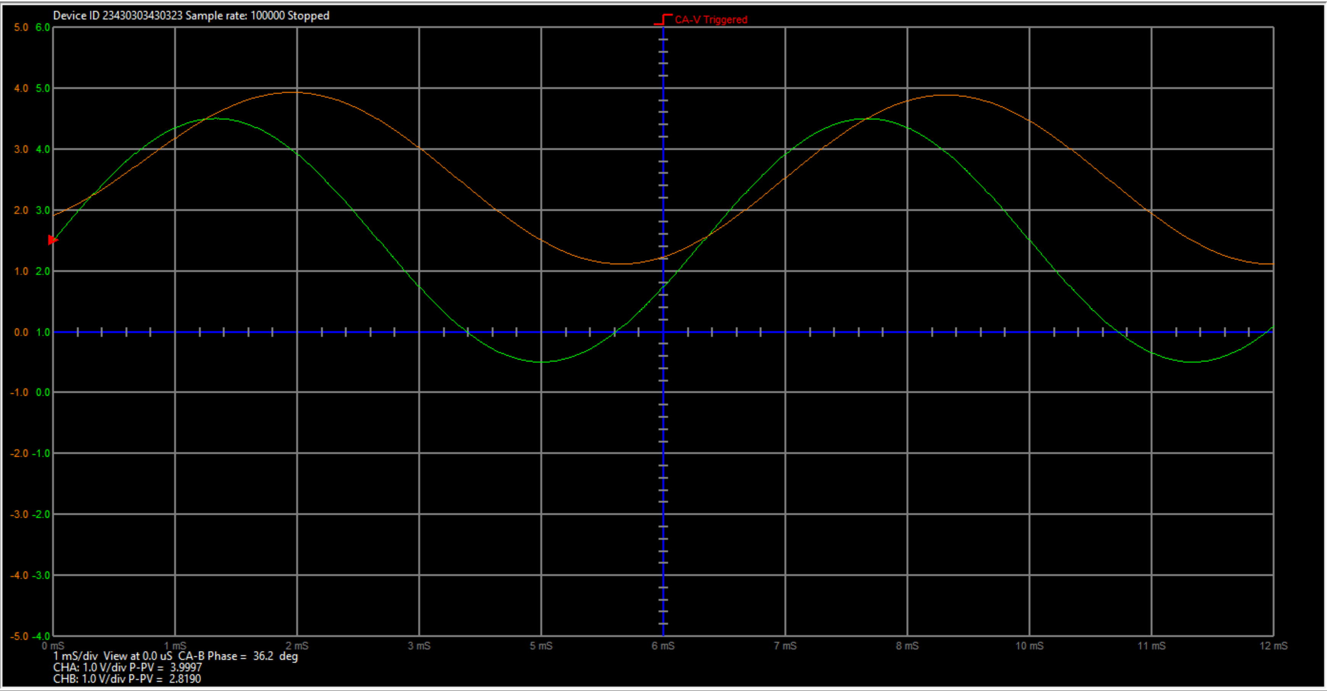

**GRAPH:**

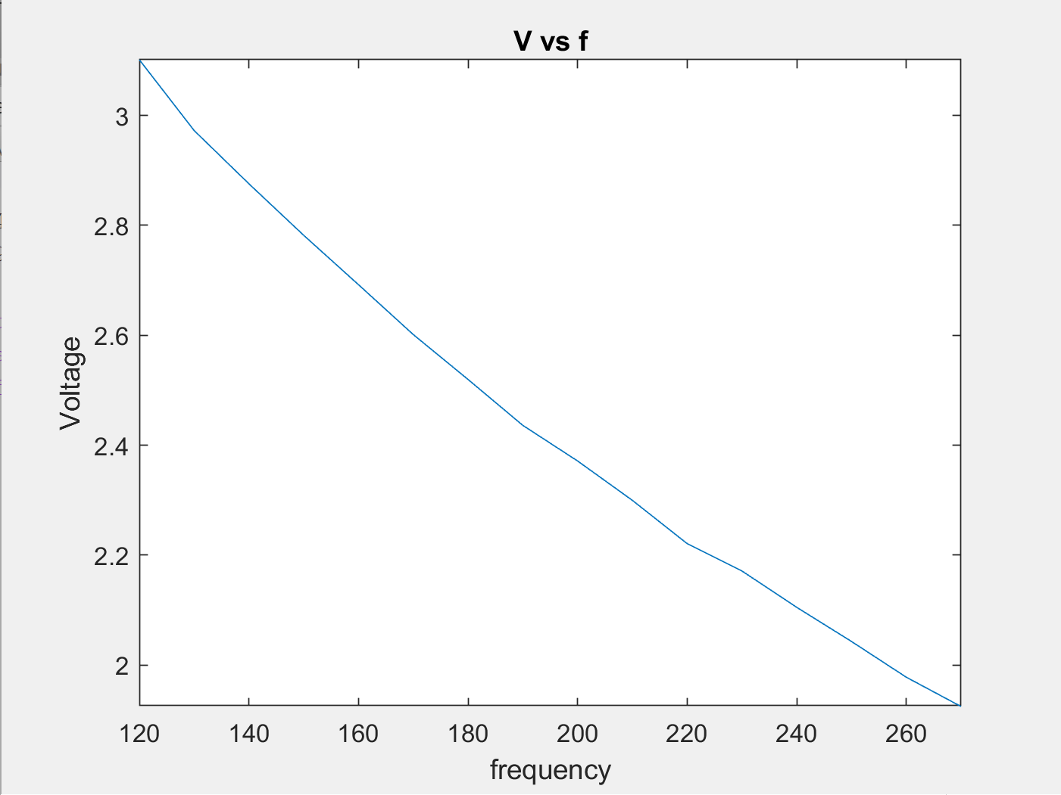

**INFERENCE:**

The above graph shows the voltage starts to decline from 120 Hz in an almost linear manner. Below 150 Hz the graph will be straight line parallel to the x-axis. There will be a slight difference of Voltage, rather than usual differences of Voltage at the corresponding frequencies, at the cut-off frequency (159.2 Hz). It finally hits 1.92 V at 270 Hz.